Saving babies’ lives: Culturally-sensitive resources launched to address unacceptably high stillbirth rates
Monday 30 October: FIRST Nations women as well as migrant and refugee women from communities disproportionately impacted by stillbirth have been involved in co-designing new culturally appropriate pregnancy resources, to save the lives of babies in their own communities.
Stillbirth rates in Australia remain tragically high, with six babies stillborn on average, every day. A suite of sensitively-crafted, in-language resources, called 'Stronger Bubba Born' and 'Growing a Healthy Baby', have been developed from the evidence-based Safer Baby Bundle to improve maternity care for these communities and contribute to reducing stillbirth rates in Australia by 20 per cent.
It is believed between 20 and 30 per cent of late gestation stillbirths are preventable with better care, however systemic healthcare barriers can prevent important discussions about stillbirth prevention.
These new resources have been developed through extensive community consultation and input from health educators, to ensure the information and illustrations are culturally appropriate and reduce the devastating impact of stillbirth on these communities.
This important work has involved two years of consultation and development, and is an extension of the Safer Baby Bundle created by the Stillbirth Centre of Research Excellence (Stillbirth CRE).
For First Nations women and their families to reduce the risk of Sorry Business Baby (stillbirth), the new Stronger Bubba Born resources include flyers and videos that are available at the Stronger Bubba Born website. These resources were developed by the Stillbirth CRE Indigenous research team with the guidance of the Indigenous Advisory Group. Delivery partner Curtin University supported the extensive consultation and
co-design process. The National Aboriginal Community Controlled Health Organisation (NACCHO) and the Waminda South Coast Women’s Health and Wellbeing Aboriginal Corporation are also collaborators with the CRE on their Indigenous work.
Arabic, Dari, Dinka and Karen-speaking communities now have access to important tailored information in the form of a written booklet, summary video and self-paced digital booklet with audio. These resources are now available at the Growing a Healthy Baby website. A network of community groups and health educators from the Multicultural Centre for Women’s Health (MCWH) and the Stronger Futures CRE at the Murdoch Children’s Research Institute (MCRI) worked with the Stillbirth CRE to develop these in-language resources.
The five key areas covered in these new resources, and the Safer Baby Bundle, include:
- Supporting women to stop smoking in pregnancy and reduce their exposure to smoke;
- Improving detection and management of fetal growth restriction;
- Raising awareness and improving care for women with decreased fetal movements;
- Education that sleeping on your side from 28 weeks of pregnancy can halve the risk of stillbirth;
- Improving decision making about the timing of birth for women with risk factors for stillbirth.

The Mater Research-based Stillbirth Centre of Research Excellence Director, Professor Vicki Flenady, said “stillbirth rates are significantly higher among First Nations and some migrant and refugee communities, compared to the general population, and we need to tackle this by ensuring these communities have care and resources that meet their needs.”

“The Safer Baby Bundle is an evidence-based initiative designed to improve maternity care and drive down stillbirth rates in Australia, and we’ve already seen it work in Victoria. These new culturally sensitive resources, which have been carefully co-designed with the communities we are seeking to reach, will be central to the work we now need to do to reduce the burden of stillbirth among women at greatest risk,” Professor Flenady said.

Senior Advisor of Indigenous Research at Stillbirth CRE, Deanna Stuart-Butler said two years of consultation across Australia - from yarning circles to community and healthcare worker interviews - went into making sure evidence-based practice was implemented in First Nations communities' own ways of “knowing, being and doing”.

“Without discounting the diversity across First Nations communities, these messages are presented in a lingo that our community speaks, understands and can relate to,” Ms Stuart-Butler said.

“Even though the clinical information is consistent with the mainstream Safer Baby Bundle messages, the way it has been presented also caters to our mob's cultural considerations, which our team thought was very important for these resources to be accepted by the community.

“We hope that this two-pronged approach of targeting women as well as clinicians through evidence-based and culturally appropriate messaging on stillbirth prevention will help reduce the number of preventable stillbirths in our First Nations communities.”

Royal Australian and New Zealand College of Obstetricians and Gynaecologists (RANZCOG) board member and Multicultural Centre for Women’s Health board member Dr Nisha Khot said many migrants came from countries where routine pregnancy care, especially in early pregnancy, wasn’t the norm and these resources communicated the reasons for that care.

“In a lot of migrant communities, there’s a sense that bad outcomes can’t be prevented. Women may feel that a stillbirth might be their fault. It’s important to communicate that, no, this is something that can be prevented and these are the ways of preventing it,” Dr Khot said.

“Having this information in a language they can understand, discussed in a culturally sensitive way, can make a difference to the stillbirth rates because women themselves can take the preventative steps that we know work.”

Dr Fatima El-Assaad gave birth to her daughter Aya, who was stillborn, in 2021. She said she realised many bereaved parents were not aware that stillbirth could happen to them.

Dr El-Assaad said GPs and midwives could have discreet conversations about stillbirth while being open to understanding what the woman knew and felt about the topic, and then use the resources to extend those conversations in a respectful way.

“Some migrant and refugee communities, and First Nations communities, have the highest rates of stillbirth in our country. If we are committed to reducing the national stillbirth rates, it is essential that these communities can access culturally sensitive resources in a language they understand. Helping communities understand the steps to progressing a safer pregnancy may help to reduce the risk of preventable stillbirths. These resources will also help health professionals engage meaningfully with these women and provide culturally sensitive and competent care,” she said.
The cultural adaptation of the Safer Baby Bundle has been funded by the Australian Government.

These new resources are available at:
- https://strongerbubbaborn.org.au/ (First Nations communities)

- https://growingahealthybaby.org.au/ (Arabic, Dari, Dinka and Karen speaking communities)

In addition, this latest information has also been translated into 25 languages and is available on the CRE’s Safer Baby website, saferbaby.org.au/, and available with all resources for healthcare professionals at learn.stillbirthcre.org.au/.
ENDS

Media are encouraged to include the links to the websites, the videos and flyers in their coverage.
Available for interview:
- Professor Vicki Flenady, Stillbirth CRE Director
- Deanna Stuart-Butler, Stillbirth CRE Senior Advisor of Indigenous Research
- Dr Nisha Khot, Royal Australian and New Zealand College of Obstetricians and Gynaecologists (RANZCOG) board member and Multicultural Centre for Women’s Health board member
- Dr Fatima El-Assaad, Director and Founder of The Still Nest, Host and Producer of The Still Nest Podcast

MEDIA CONTACTS: Jessica Marszalek, 0404 079 244, jessica@89degreeseast.com or
Andrew Reid, 0412 335 258, andrewr@89degreeseast.com

BACKGROUND:
The rate of stillbirth in Australia was 7.7 per 1,000 births in 2020. First Nations Australians experience relatively higher rates at 11.9 per 1,000 births compared to 7.4 per 1,000 births for non-Indigenous Australians.
Women from some migrant backgrounds, including those from Central and Western Africa (14 per 1,000 births), Central Asia (11.2 per 1,000 births), Southern Asia (9.1 per 1,000 births), and Middle East (8.9 per 1,000 births) have higher rates of stillbirth than women born in Australia (7.7 per 1,000 births).
These priority groups were identified for stillbirth prevention as outlined in the National Stillbirth Action and Implementation Plan (NSAIP).
Stillbirth is preventable in many cases and as many as 20-30% of late gestation stillbirths could be avoided with better care.
Stillbirth CRE is an Australia-wide initiative, our host institution being Mater Research Institute, within The University of Queensland Faculty of Medicine.
The cultural adaptation of the Safer Baby Bundle has been funded by the Australian Government.

These cultural adaptation projects follow the roll-out to all Australian states of the Safer Baby Bundle - a resource funded by the federal government under the National Stillbirth Action and Implementation Plan (NSAIP) to reduce stillbirth rates by 20 per cent.

Stillbirth CRE partners for Stronger Bubba Born and Indigenous projects

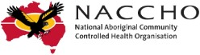


Stillbirth CRE partners for Growing a Healthy Baby migrant and refugee project
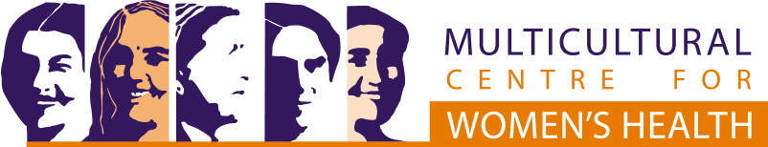
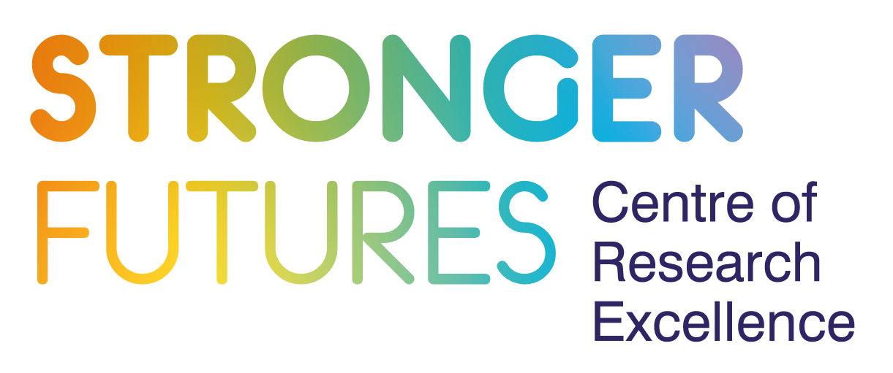

Support services are available to families affected by the death of a baby or child.

Phone the Red Nose and Sands’ 24/7 support line on 1300 308 307 or Bears of Hope Pregnancy and Infant Loss Support on 1300 114 673.

