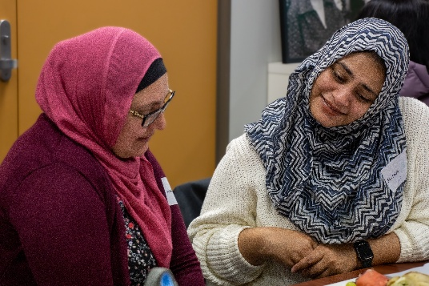
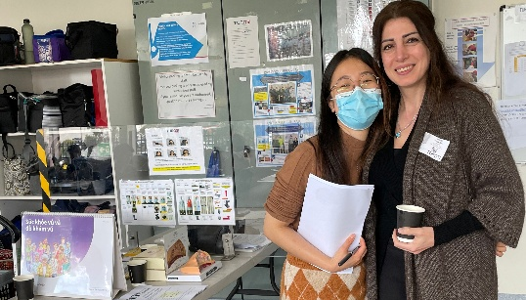



MCWH’s state election priorities:
Building a health system that works for every woman in Victoria
Victoria has an established women’s health infrastructure, which includes women’s health clinics, sexual and reproductive health hubs, and the 12 women’s health services.
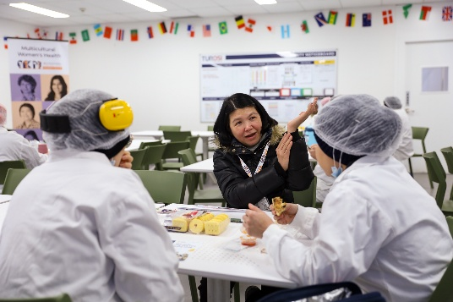
In the lead-up to the Victorian election, the Multicultural Centre for Women’s Health (MCWH) supports ongoing, sustained funding for the Victorian women’s health infrastructure, with embedded supports to ensure that services are culturally safe and that migrant and refugee women have equitable access to the women’s health services they need.

To ensure migrant and refugee women have equitable access to the women’s health infrastructure and culturally safe services, MCWH calls for these four priorities in the 2026 election:

3. Increase multilingual access through 1800 My Options
Strengthen 1800 My Options as a single-entry point to Victoria’s sexual and reproductive health system by increasing its capacity to provide multilingual information, support and referrals. More women callers should have the option to speak with a responder in their language.

4. Establish a multilingual women’s health hub in Melbourne’s CBD
Provide a multilingual drop-in women’s health information hub in Melbourne staffed by trained bilingual educators. Every woman and gender diverse person deserves to have a space where they can talk confidentially and freely with someone they trust, in a language they understand.

1. Expand bilingual women’s health education and outreach
Deliver more outreach, bilingual women’s health education across Victoria to support service navigation and build awareness of local services. Every woman and gender diverse person should know about the health services in their local area and how to access them.
2. Improve health outcomes for migrant and refugee women living in regional and rural Victoria
Provide in-language information to migrant and refugee women in rural areas to complement the activities of the mobile women’s health clinic and coinciding with their visits. Every rural woman should have access to
the mobile clinic, including services in their language.

